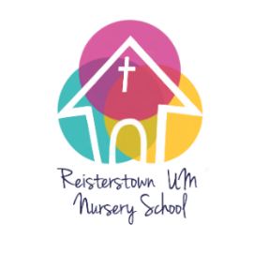
Reisterstown United Methodist Nursery School
246 Main Street, Reisterstown, MD 21136
RUMNS234@gmail.com 443-546-0585
2024 Registration for Summer Camp Program
Registration is available for 3’s and 4’s and PreK 5’s

I have received and read the Parent Handbook for childcare at RUMNS. I understand and agree to the statements as written and will abide by them, understanding that regulations may change based on changing laws and guidelines. If I ignore or abuse these policies, including excessive late pickups, I understand that I may be asked to find alternative childcare. I have received a copy of the Parents Guide To Regulated/Licensed Child Care.

I agree to pay the childcare fees as stated below, and to be prompt with payment. Payment is due on the date listed for each week of camp and is non-refundable or transferable after that date. I understand that that if payment is not made on time, my child may not participate in RUMNS’s program. Children who are not fully potty trained will incur an additional $25 surcharge. Children with non-medical dietary accommodations will incur an additional $25 snack fee.

My Child will be participating in the following weeks of the Summer Program:

TUITION of $225 is DUE ON:
_____Week 1: June 24-June 28 June 10

_____Week 2: July1 -July 5 (no camp on July 4) June 24

_____Week 3: July 8 July 12 July 1

_____Week 4: July 15 – July 19 July 8

_____Week 5: July 22– July 26 July 15

_____Week 6: July 29 – August 2 July 22

_____Week 7: August 5 – August 9 July 29

_____Week 8: August 12 – August 16 August 5

FEES: $225 per week : 7:45am-5:30pm (breakfast at 8:20, morning and afternoon snack included)
ENROLLMENT REGISTRATION FEE: $25 per week due with contract.
Your space will not be held until non-refundable deposit is paid.
Tuition for all 8 weeks is $1800, fees incurred for late pickup are extra.
LATE PICKUP FEE: $3 per minute, per child, after 5:30pm. Please be prompt.

Cash, check, or money order accepted in person. Please make check payable to RUMNS. A fee of $35 will be charged for all returned checks. You can also pay on our website for a processing fee of an additional $10 per week.

Child’s Name:_____________________________________________ Age on September 1, 2024:___________

Parent’s name (printed):_________________________________________________________

Address: _____________________________________________________________________________________

Email Address: _________________________________________________ Cell Phone : _______________________

Parent’s Signature:_____________________________________________ Date:____________
R.U.M.N.S. Summer Program!

Our summer camp is filling up fast!
Don’t delay if you are considering a spot this summer.

Your child can join us this summer where we will explore indoors and outdoors. Children will enjoy arts and crafts, nature exploration, playground time, water fun, and academic enrichment with their friends.

Enroll only for the weeks you will need.
Enrollment will be limited to 1 class, ages 3 to 5
Children must be potty trained.

June 24 – June 28 Dr, Seuss
July 1 – July 5 Cooking up Some Fun
July 8 – July 12 Art Exploration
July 15 – July 19 Bible Stories
July 22 – July 26 Superheroes
July 29 – August 2 Off to Alaska
August 5 – August 9 Under Construction
August 12 – August 16 Anything Goes!

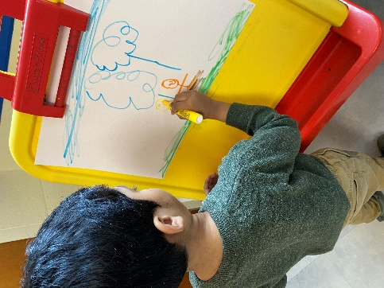
$225 per week
$25 registration per week

