Our 2's program provides a safe nurturing first learning environment. Our free play, small group activities, and circle time encourages social interaction. Children are introduced to a structured yet flexible daily plan designed to help children transition easily from home to school.  Our 3's program fosters positive relationships with peers and adults to play and work cooperatively. Age appropriate activities promote development of fine and gross motor skills in preparation for reading and writing.  We use movement and a multi-sensory approach to skill building.  Our 4's program develops skills and confidence needed to build a strong foundation for kindergarten and beyond. Children are encouraged to take care of their own needs, environment, and community. We provide an atmosphere where each child can grow and learn in their own unique way.  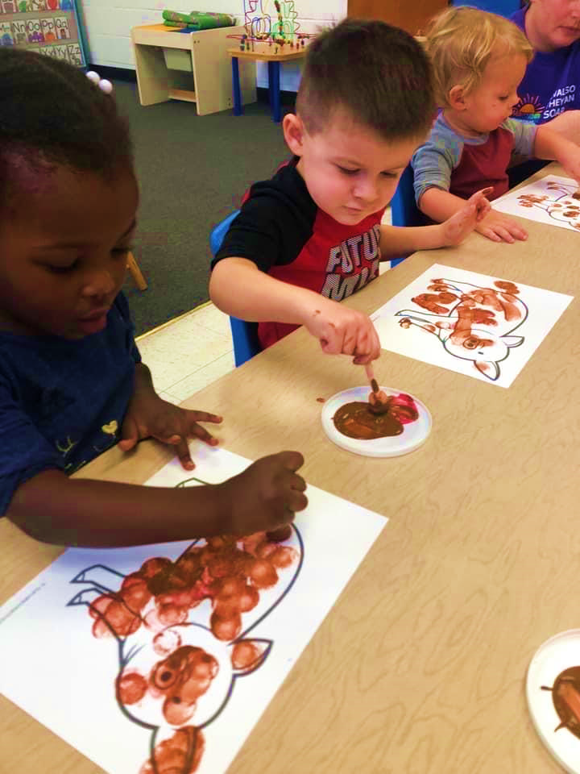 |  | We offer the following programs:  Half Day Preschool Program: 8:50 am – 12 noon  For 2 year olds $4050  For 3 or 4 year olds $3750  Full Day Program: 7:30 am – 5:30 pm  For 2 year olds $9750  For 3 or 4 year olds $8850  Program includes breakfast and 2 snacks  All Programs run Monday through Friday  September 5 – June 13  Our preschool program has been in Reisterstown for 39 years. Our graduates have been successful in transitioning into both public and private kindergartens.  Contact Us  RUMNS234@gmail.com  Kirstyn Hutchinson – Director – 410-387-9911  Visit our Website: www.rumns.com  rumns234@gmail.com  443-996-9375  RUMNS 2023-2024  246 Main Street  Reisterstown, MD 21136  Lani Hoffmann – Registrar – 443-996-9375 |  | RUMNS 2023-2024  - Reisterstown United Methodist Nursery School

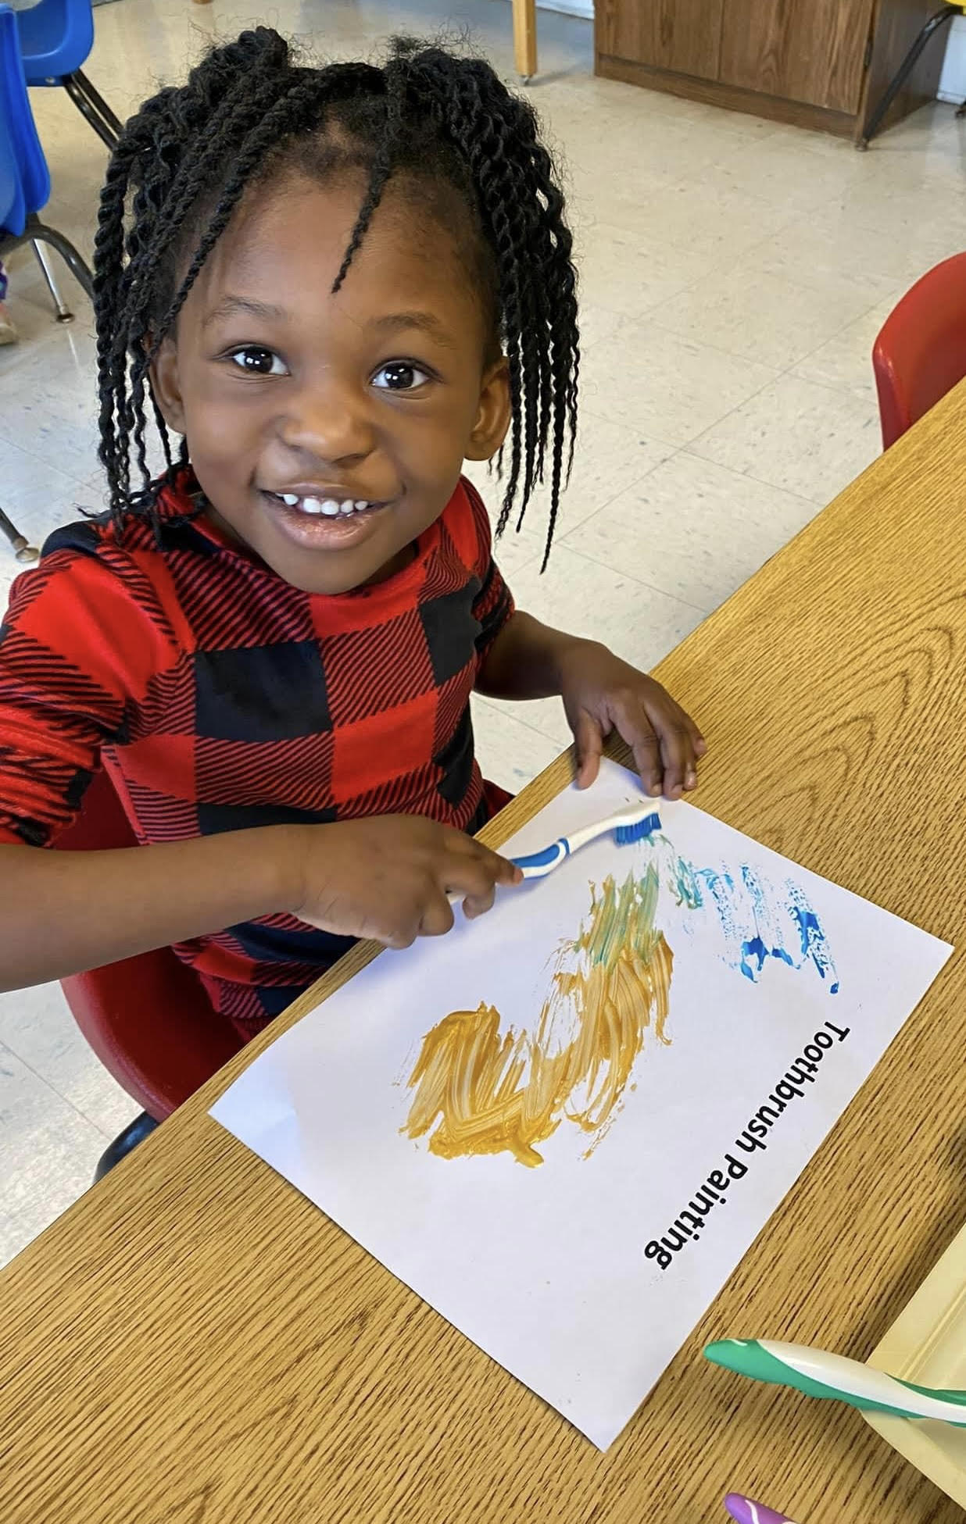  Over 30 years serving the Reisterstown Community!  Our nursery school has been part of the Reisterstown community since 1984. We have sent forth many generations of students ready for school and life -long learning. Our goal is to have our children go forth enthusiastically with confidence in their own abilities and ideas with a firm foundation of skills, a thirst for more knowledge and the assurance that God loves them. We believe that instilling a love of learning in a child is the most effective way to prepare him for further education.  Classes run September to mid-June. We also run a summer camp program for those needing year-round care. |  |  | Our Director, Ms. Hutchinson has her Early Childhood Certification from the Maryland Institute for Teachers, and her School Age Certification from Howard Community College. She has been working with children of all ages for 25 years.  “I could not be happier with my son’s progress at RUMNS. We love our teachers!”  Our Mission:  As a ministry of the church, our mission is to offer the children an introduction to the love of God, age-appropriate Bible stories, and a solid introduction to living as a disciple while at the same time offering hands-on learning experiences that prepare them for elementary school. Our hope is that each child will experience the joy of learning in a loving, caring, Christian environment. Our program focuses on how children learn through play, socialization, and movement. We encourage children to explore their world through all of their senses and to develop a sense of wonder for the God who creates. Our activities are designed to help children grow intellectually, socially, emotionally, physically, and spiritually. We encourage independence, respect and good moral character. |  |  | “Play is the work of the child”- Maria Montessori  2023-2024 school calendar:  Sept. 5 - school opens  Oct.20 – school closed MSEA conference  Nov.10 - school closed for church event.  Nov.22- 24 – school closed for Thanks.  Dec 20-31 – school closed for Christmas  Jan. 2 – school reopens  Jan. 15– school closed for MLK  Feb. 19– school closed for President Day  March 25-April 2 – closed for Easter  May 27– school closed for Memorial Day  June 13 – last day of classes  June 14 – school picnic – last day for year  Our program also offers in-house enrichment programs including author visits, science programs, animal and reptile programs, dance classes, nature walks, scavenger hunts, pumpkin patches, Easter egg hunts, Santa visits, and more.

