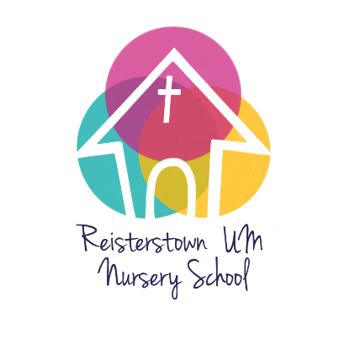
R.U.M.N.S. Photo Release

Child’s Name ________________________________________________________

As a school, we like to photograph the children in play and learning situations. We need your permission to be able to display those photos. We will NEVER include children’s names with our photos. Please consider each situation carefully and indicate whether your child is to be included in those photos.

I give my permission for my child’s photo to be used in the following manner:

Please initial YES or NO

Yes No
Printed copy of the photo to be used in crafts the child brings home
Printed copy of the photo that would be used in group crafts and sent home with other children: ex. Class photos or groups of friends together
Photos that are sent home to the parents electronically
Classroom/School displays/bulletin boards (in the building only)
Church displays/bulletin boards (in the building only)
Web page for school
Web page for church
Other social media pages (such as Facebook and Instagram)
Print materials for advertising and informational purposes
Digital advertising

Parent Name (print)_______________________________________________

Parent Signature ___________________________________________Date_______________

